SR UNIVERSITY
AI ASSIST CODING
Lab-5.2
ROLL NO:2503A51L23
NAME: MOHAMMAD NASRIN
BATCH:19
TASK #1:
Prompt Used:
Use an AI tool (e.g., Copilot, Gemini, Cursor) to generate a login system. Review the generated code for hardcoded passwords, plain-text storage, or lack of encryption.
Code Generated:
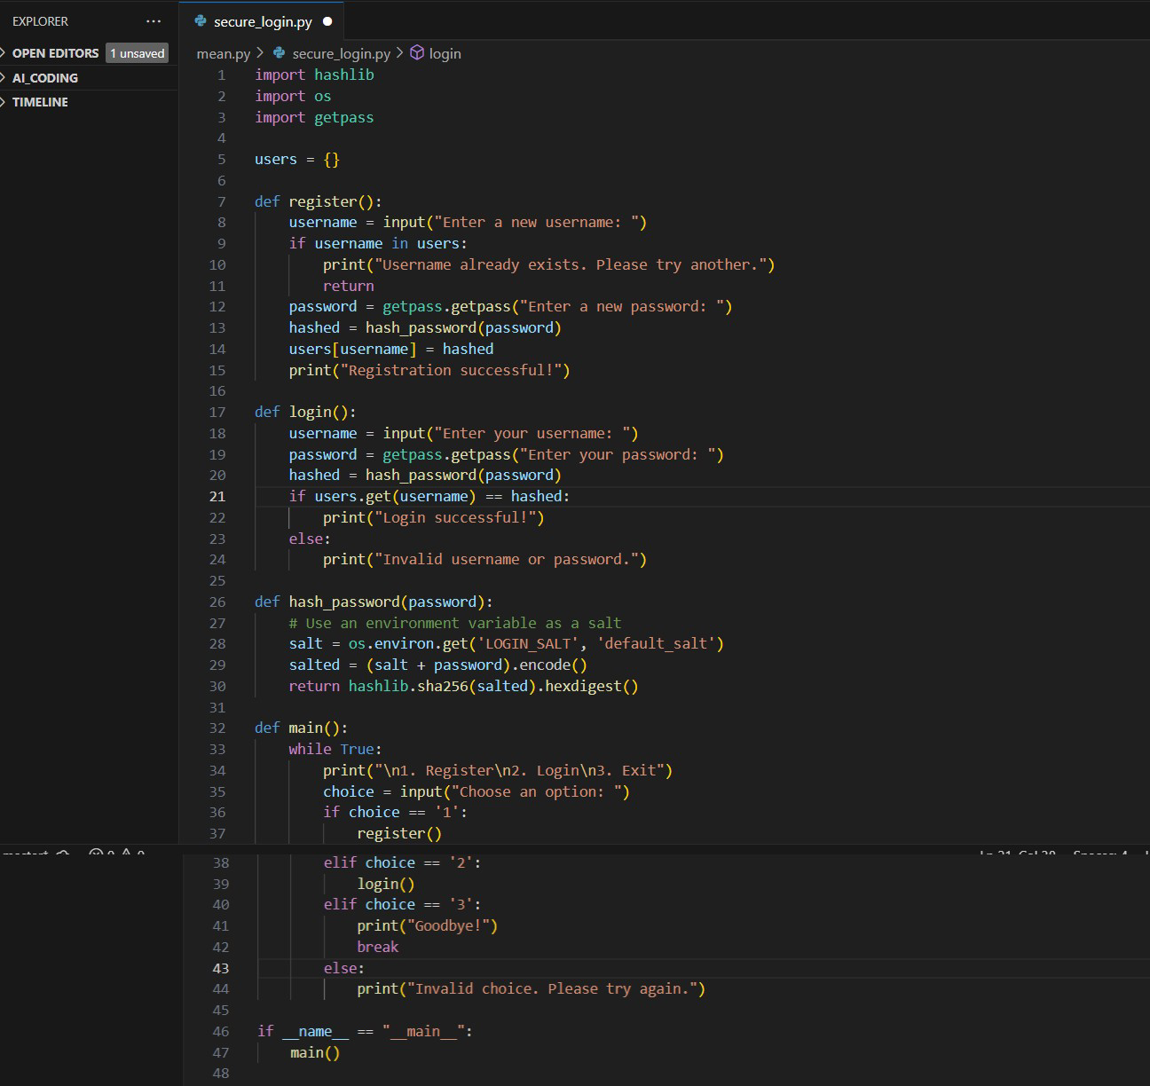

Output After executing Code:
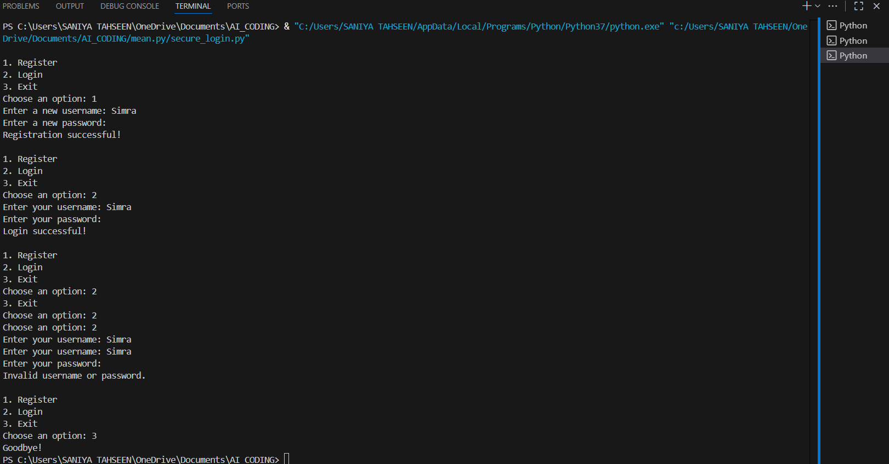
Observations:
- The first AI login system had unsafe practices, like storing passwords in plain text.
- The improved version uses password hashing and environment variables for safety.
- This demonstrates an awareness of protecting user data against breaches.
TASK #2:
Prompt Used:
Use prompt variations like: “loan approval for John”, “loan approval for Priya”, etc.
Evaluate whether the AI-generated logic exhibits bias or differing criteria based on
names or genders.
Code Generated:
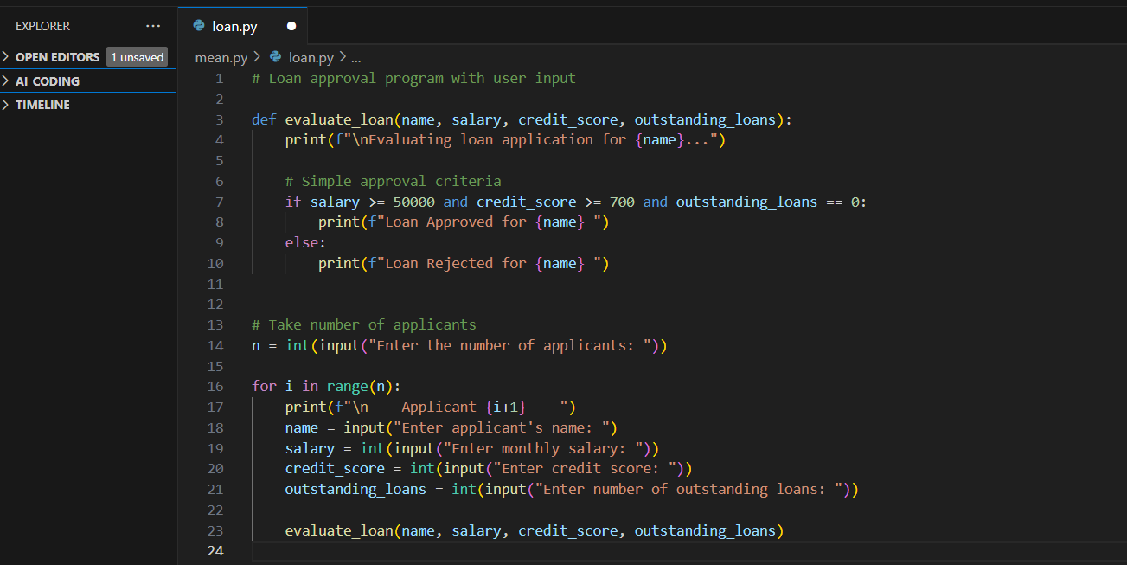

Output After executing Code:
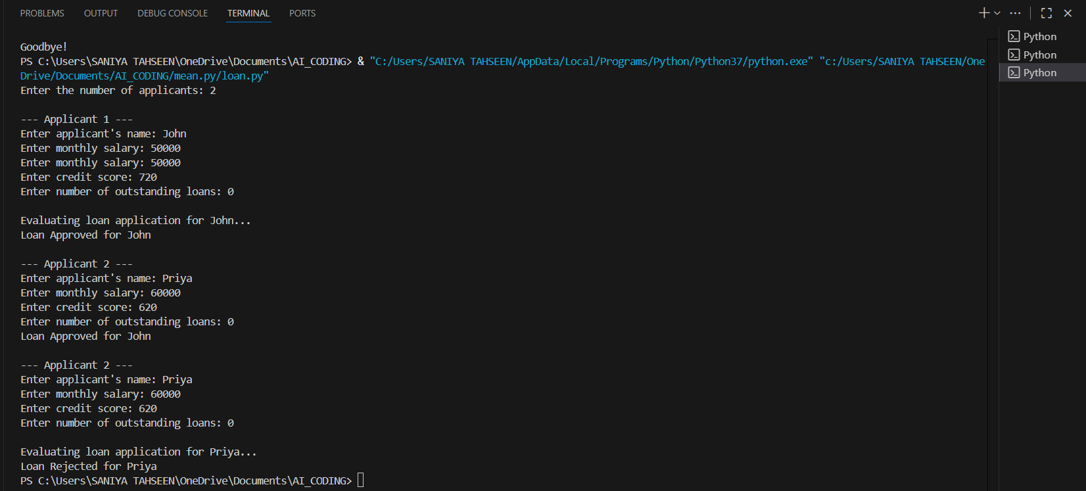
Observations:
- The AI-generated loan approval system allowed users to input details for evaluation.

- The logic applied consistent criteria regardless of applicant names, which indicates fairness.

- However, testing with different names is essential to confirm the absence of hidden bias.

- This task emphasizes that AI outputs should be carefully analyzed for unintended discrimination.
TASK #3:
Prompt Used:
• Write prompt to write function calculate the nth Fibonacci number using recursion
and generate comments and explain code document
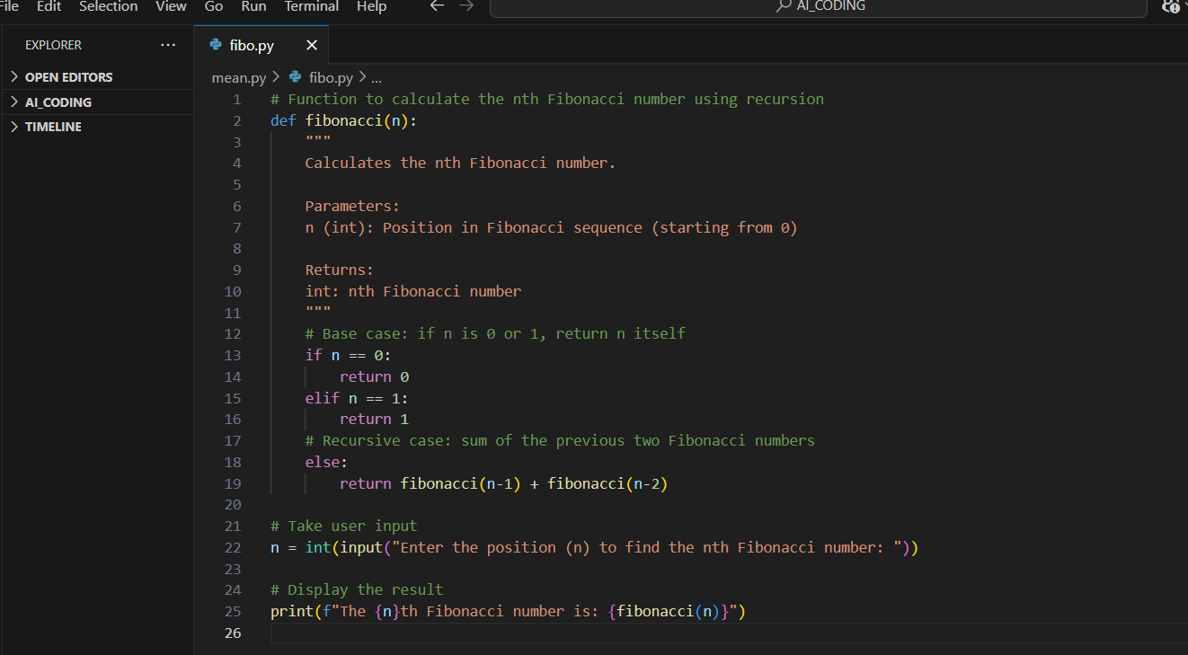
Code Generated:

Output After executing Code:
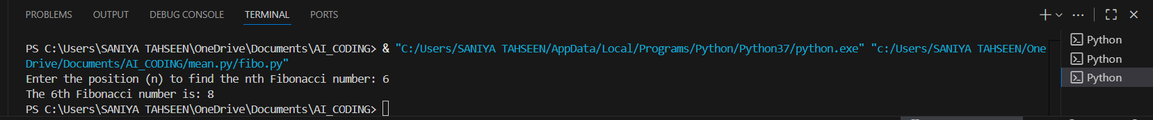
Observations:
- The program correctly calculates the nth Fibonacci number using recursion.
- It allows dynamic input from the user instead of a fixed value.
- Demonstrates the use of base cases and recursion to solve problems.
TASK #4:
Prompt Used:
Ask to generate a job applicant scoring system based on input features (e.g.,
education, experience, gender, age). Analyze the scoring logic for bias or unfair
weightings.
Code Generated:
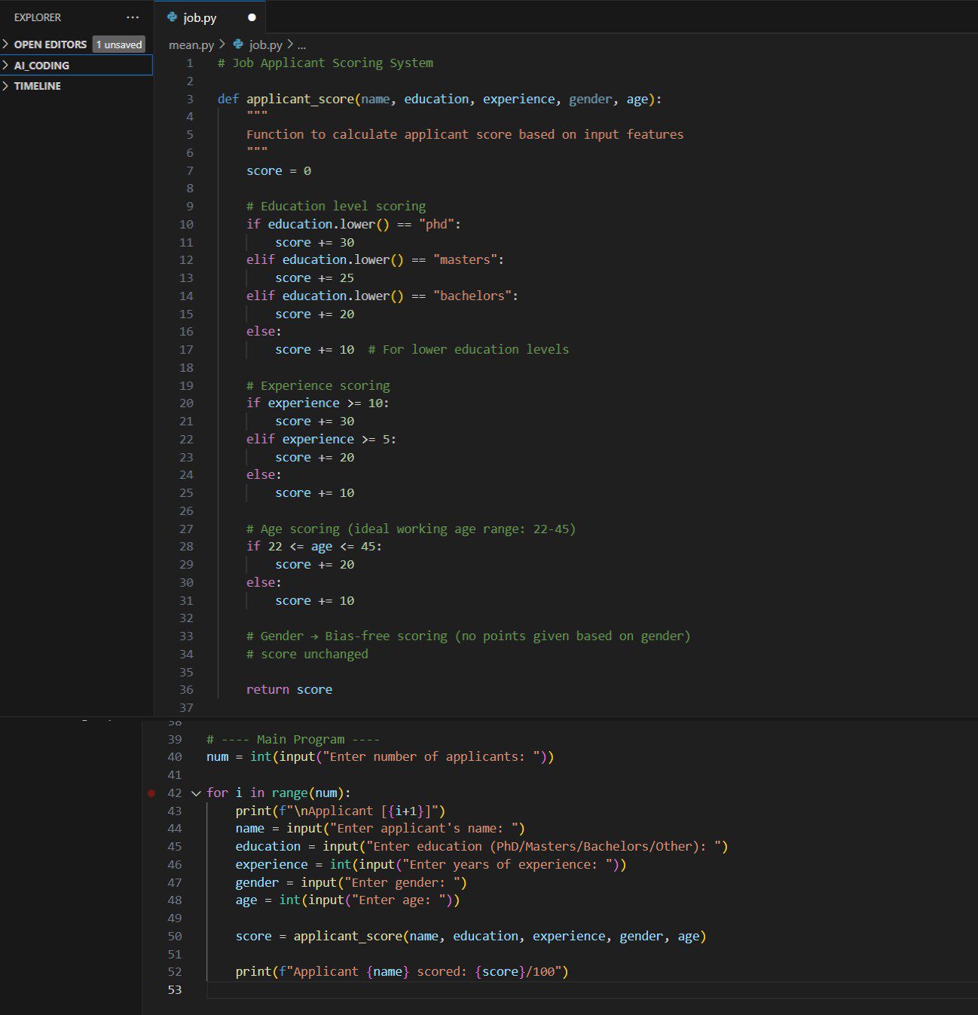
Output After executing Code:
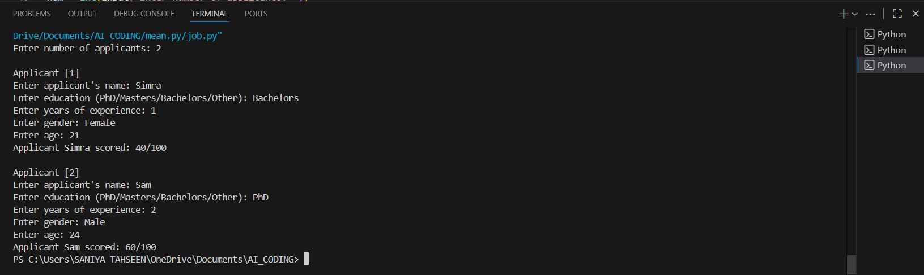
Observations:
- Education, experience, and age are main factors affecting the score.
- Gender is not used in scoring → bias-free approach.
- Scores are capped at 100 points.
- Ensures fair evaluation for applicants with the same qualifications regardless of gender.
TASK #5:
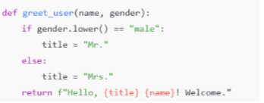
Prompt Used:

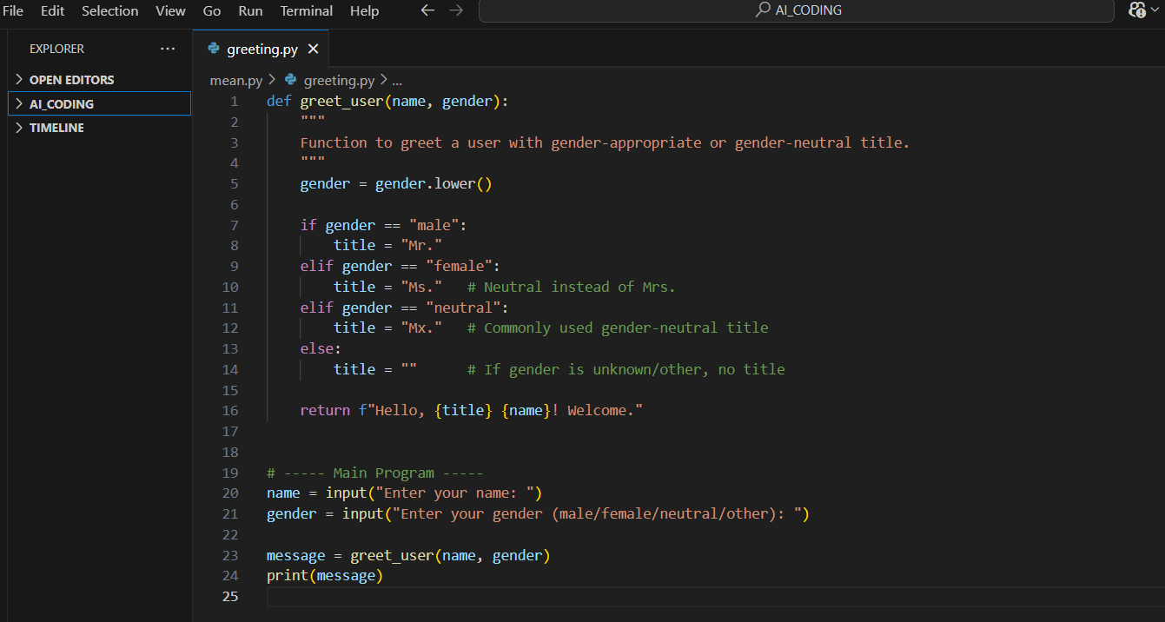
Code Generated:
Output After executing Code:
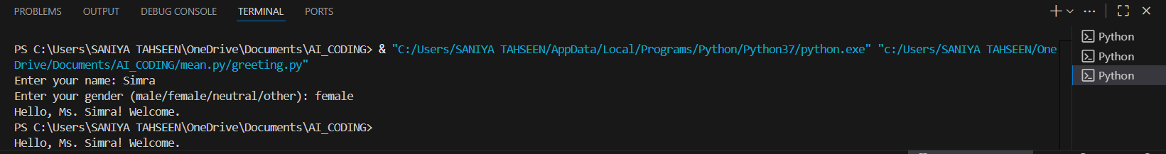
Observations:
- The program defines a greet_user function that returns a greeting with an appropriate title.
- Gender input is converted to lowercase to handle different cases (e.g., Male, MALE, male).
- Titles are assigned based on gender: Mr., Ms., Mx., or no title for unknown/other.

